

**Python Based Employee Attendance**

**Monitoring With MySQL Integration**

Group 10:

|  |  |
| --- | --- |
| Bergas Ahmad Ardiansyah | (2320010123) |
| Muhammad Ammar Abdullah | (2320010151) |

Faculty:

Ivan Firdaus, S.T

Class:

3CS1

CEP CCIT FACULTY OF ENGINEERING UNIVERSITY OF INDONESIA

2024

|  |
| --- |
| **PROJECT INFORMATION** |

|  |
| --- |
| Project Title : Python Based Employee Attendance Monitoring With MySQL Integration  Batch Code : 3CS1  Start Date : September 10th, 2024  End Date : September 29th, 2024  Name of Faculty : Ivan Firdaus, S.T  Names of Developers:   1. Bergas Ahmad Ardiannsyah 2. Muhammad Ammar Abdullah     Date of Submission: October 1st, 2024 |

|  |
| --- |
| The authors would like to express their gratitude to Allah, the Most Merciful, for His guidance and blessings, which have enabled them to complete Project 3, titled “Python-Based Employee Attendance Monitoring With MySQL Integration.” In addition, the authors wish to thank Mr. Ivan Firdaus, ST, for his insightful suggestions and continuous support throughout the writing of this project. His input has been invaluable in helping the authors enhance the quality of their work.  This paper provides an in-depth explanation of configuring a database in Python and integrating it with MySQL. The content also serves as a helpful resource for students to better understand the principles of Object-Oriented Programming, especially in the context of this third-semester project. Through this work, readers are expected to gain practical knowledge in developing database applications using Python.  Depok, 29th September 2024  Authors |

|  |
| --- |
| For this system, the authors developed a MySQL database integrated with Python using Visual Studio Code. The database created revolves around a Restaurant System Management, which consists of three tables: Menu Category, Main Menu, and Sales. This project demonstrates how Python can be used to interact with a MySQL database to effectively manage restaurant data.  The benefit of this project lies in the ability to both create and modify the MySQL database using Python. By working on this project, the authors gained practical experience in developing a database system and learned how to manage it programmatically, which is highly applicable for real-world use cases. |

|  |
| --- |
| **ERD** |

|  |
| --- |
|  |

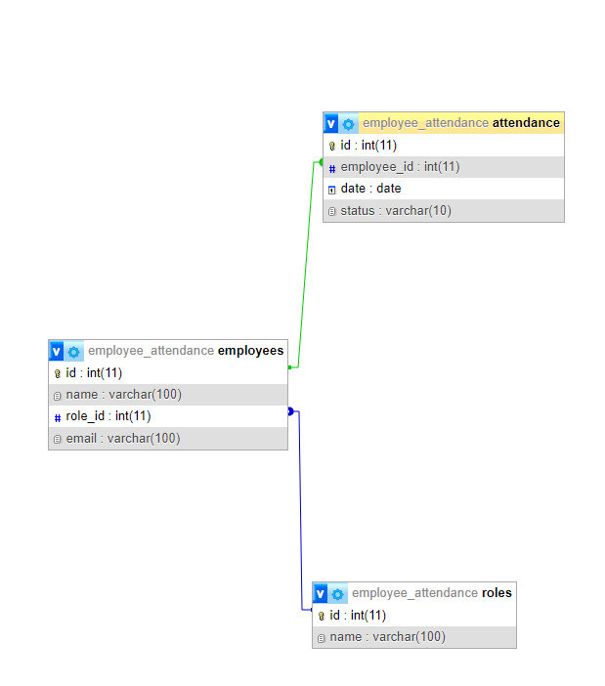

|  |
| --- |
| **TABLES** |

1. employee Table :

|  |  |  |  |  |
| --- | --- | --- | --- | --- |
| Column Name | Data Type | Size | Description | Status |
| id | INT | Auto Increment | Unique identity number | PK |
| name | VARCHAR | 100 | Employee’s name | - |
| department_id | INT | - | Unique identity number | FK (departments.id) |
| email | VARCHAR | 100 | Employee’s email |  |

1. attendance Table :

|  |  |  |  |  |
| --- | --- | --- | --- | --- |
| Column Name | Data Type | Size | Description | Status |
| id | INT | Auto Increment | Unique identity number | PK |
| employee_id | INT | - | Unique identity number | FK (employee.id) |
| date | DATE | - | Attendance’s date | - |
| status | INT | - | Attendance’s status | - |

1. departments Table :

|  |  |  |  |  |
| --- | --- | --- | --- | --- |
| Column Name | Data Type | Size | Description | Status |
| id | INT | Auto Increment | Unique identity number | PK |
| name | INT | - | Department’s name | - |

|  |
| --- |
| **AD-AD CONFIGURATION** |

1. employee Table :

|  |  |
| --- | --- |
| **Validation Requires** | **Validation Perfomance** |
| id : No user input needed since it is auto-generated, ensuring uniqueness and non-null values. | id : The **auto increment** feature guarantees uniqueness and non-null values, enforced by the primary key constraint. |
| departmens_id : Must be a INT and not null as it references another table (foreign key employee.id). | Id : A foreign key constraint (FK) ensures it references a valid category ID in the departments.id table. |

1. attendance Table :

|  |  |
| --- | --- |
| **Validation Requires** | **Validation Perfomance** |
| id : No user input needed since it is auto-generated, ensuring uniqueness and non-null values.. | id: The **auto increment** feature guarantees uniqueness and non-null values, enforced by the primary key constraint. |
| employee_id : Must be a INT and not null as it references another table (foreign key employee.id). | id_category : A foreign key constraint (FK) ensures it references a valid category ID in the employee.id table. |

1. departments Table :

|  |  |
| --- | --- |
| **Validation Requires** | **Validation Perfomance** |
| id: No user input needed since it is auto-generated, ensuring uniqueness and non-null values.. | id : The **auto increment** feature guarantees uniqueness and non-null values, enforced by the primary key constraint. |

CREATE DATABASE employee_attendance;

USE employee_attendance;

CREATE TABLE departments (

id INT AUTO_INCREMENT PRIMARY KEY,

name VARCHAR(100) NOT NULL

);

CREATE TABLE employees (

id INT AUTO_INCREMENT PRIMARY KEY,

name VARCHAR(100) NOT NULL,

department_id INT,

email VARCHAR(100) NOT NULL,

FOREIGN KEY (department_id) REFERENCES departments(id)

);

CREATE TABLE attendance (

id INT AUTO_INCREMENT PRIMARY KEY,

employee_id INT,

date DATE,

status VARCHAR(10),

FOREIGN KEY (employee_id) REFERENCES employees(id)

);

**TYPESCRIPT**

Query Creating Database in MYSQL

import mysql.connector

from datetime import datetime

# Connection to MySQL database

def get_connection():

    return mysql.connector.connect(

        host="localhost",

        user="root",

        database="employee_attendance"

    )

**TYPESCRIPT**

Connecting Python to Database MySQL

**# Function to add an employee (Create)**

def add_employee(name, role_id, email):

    conn = get_connection()

    cursor = conn.cursor()

    query = "INSERT INTO employees (name, role_id, email) VALUES (%s, %s, %s)"

    cursor.execute(query, (name, role_id, email))

    conn.commit()

    conn.close()

    print("Employee successfully added.")

**# Function to list all employees (Read)**

def list_employees():

    conn = get_connection()

    cursor = conn.cursor()

    cursor.execute("SELECT employees.id, employees.name, roles.name, employees.email FROM employees JOIN roles ON employees.role_id = roles.id")

    result = cursor.fetchall()

    conn.close()

    for row in result:

        print(f"ID: {row[0]}, Name: {row[1]}, Role: {row[2]}, Email: {row[3]}")

**# Function to update employee data (Update)**

def update_employee(employee_id, name=None, role_id=None, email=None):

    conn = get_connection()

    cursor = conn.cursor()

    updates = []

    params = []

    if name:

        updates.append("name=%s")

        params.append(name)

    if role_id:

        updates.append("role_id=%s")

        params.append(role_id)

    if email:

        updates.append("email=%s")

        params.append(email)

    params.append(employee_id)

    query = f"UPDATE employees SET {', '.join(updates)} WHERE id=%s"

    cursor.execute(query, params)

    conn.commit()

    conn.close()

    print("Employee data successfully updated.")

**TYPESCRIPT**

CRUD Function Script in Pytthon

**# Function to get employee details by ID (Read)**

def get_employee_by_id(employee_id):

    conn = get_connection()

    cursor = conn.cursor()

    query = """

        SELECT employees.id, employees.name, roles.name, employees.email

        FROM employees

        JOIN roles ON employees.role_id = roles.id

        WHERE employees.id = %s

    """

    cursor.execute(query, (employee_id,))

    result = cursor.fetchone()

    conn.close()

    if result:

        print(f"\n--- Employee Details ID {employee_id} ---")

        print(f"ID: {result[0]}")

        print(f"Name: {result[1]}")

        print(f"Role: {result[2]}")

        print(f"Email: {result[3]}")

    else:

        print(f"Employee with ID {employee_id} not found.")

**# Function to delete an employee (Delete)**

def delete_employee(employee_id):

    conn = get_connection()

    cursor = conn.cursor()

    cursor.execute("DELETE FROM employees WHERE id=%s", (employee_id,))

    conn.commit()

    conn.close()

    print("Employee successfully deleted.")

**# Function to add check-in attendance (Create)**

def add_attendance_in(employee_id):

    conn = get_connection()

    cursor = conn.cursor()

    date_today = datetime.now().date()

    time_in = datetime.now().time()

    query = "INSERT INTO attendance (employee_id, date, status) VALUES (%s, %s, %s)"

    cursor.execute(query, (employee_id, date_today, f"Check-in: {time_in}"))

    conn.commit()

    conn.close()

    print("Check-in attendance successfully added.")

**TYPESCRIPT**

CRUD Function Script in Pytthon

**# Function to add check-out attendance (Create)**

def add_attendance_out(employee_id):

    conn = get_connection()

    cursor = conn.cursor()

    date_today = datetime.now().date()

    time_out = datetime.now().time()

    query = "INSERT INTO attendance (employee_id, date, status) VALUES (%s, %s, %s)"

    cursor.execute(query, (employee_id, date_today, f"Check-out: {time_out}"))

    conn.commit()

    conn.close()

    print("Check-out attendance successfully added.")

**# Function to list attendance for an employee (Read)**

def list_attendance(employee_id):

    conn = get_connection()

    cursor = conn.cursor()

    query = "SELECT date, status FROM attendance WHERE employee_id=%s"

    cursor.execute(query, (employee_id,))

    result = cursor.fetchall()

    conn.close()

    for row in result:

        print(f"Date: {row[0]}, Status: {row[1]}")

**# Function to choose a role (Read)**

def choose_role():

    roles = ["Director", "Manager", "Marketing", "Employee"]

    for i, role in enumerate(roles, 1):

        print(f"{i}. {role}")

    choice = int(input("Choose Role (1-4): "))

    if choice in range(1, 5):

        return choice

    else:

        print("Invalid choice. Please try again.")

        return choose_role()

**TYPESCRIPT**

CRUD Function Script in Pytthon

**# Employee Main  Menu**

def main_menu():

    while True:

        print("\n=== Employee Attendance System ===")

        print("1. Employee Administration")

        print("2. Attendance")

        print("99. Exit")

        choice = input("Choose an option: ")

        if choice == "1":

            employee_admin_menu()

        elif choice == "2":

            attendance_menu()

        elif choice == "99":

            print("Exiting the program...")

            break

        else:

            print("Invalid choice. Please try again.")

**# Attendance Menu**

def attendance_menu():

    while True:

        print("\n--- Attendance Menu ---")

        print("1. Add Check-in")

        print("2. Add Check-out")

        print("3. View Attendance")

        print("99. Return to Main Menu")

        choice = input("Choose an option: ")

        if choice == "1":

            employee_id = input("Employee ID: ")

            add_attendance_in(employee_id)

        elif choice == "2":

            employee_id = input("Employee ID: ")

            add_attendance_out(employee_id)

        elif choice == "3":

            employee_id = input("Employee ID: ")

            list_attendance(employee_id)

        elif choice == "99":

            return

        else:

            print("Invalid choice. Please try again.")

**TYPESCRIPT**

Menu Function Script in Pytthon

**# Employee Administration Menu**

def employee_admin_menu():

    while True:

        print("\n--- Employee Administration Menu ---")

        print("1. View All Employees")

        print("2. View Employee by ID")

        print("3. Update Employee")

        print("4. Delete Employee")

        print("99. Return to Main Menu")

        choice = input("Choose an option: ")

        if choice == "1":

            list_employees()

        elif choice == "2":

            employee_id = input("Enter Employee ID: ")

            get_employee_by_id(employee_id)

        elif choice == "3":

            employee_id = input("Employee ID: ")

            name = input("New name (leave blank if not changing): ")

            print("Choose new role (leave blank if not changing):")

            role_id = choose_role()

            email = input("New email (leave blank if not changing): ")

            update_employee(employee_id, name or None, role_id, email or None)

        elif choice == "4":

            employee_id = input("Employee ID: ")

            delete_employee(employee_id)

        elif choice == "99":

            return

        else:

            print("Invalid choice. Please try again.")

if __name__ == "__main__":

    main_menu()

**TYPESCRIPT**

Menu Function Script in Pytthon

**Hardware : Asus TUF F15 & HP Pavilion G15**

**OS : WINDOWS 11**

**Software :Visual Code Studio, XAMPP MySQL, Python**

|  |  |  |
| --- | --- | --- |
| **PROJECT FILE DETAILS** | | |
| NO | File Name | Remarks |
| 1 | .docx | Bergas A. Ardiansyah |
| 2 | .pptx | Muhammad Ammar Abdullah |

**Hardware Configuration**